
Cloud IDE REPORT
By Aaron Cairns


Introduction

A Cloud IDE, also known as a Cloud Integrated Development Environment, is an online platform that allows developers to write, edit, test and run code directly through a web browser. Unlike traditional IDEs, which normally need to be downloaded and installed onto a computer. Cloud IDEs are hosted on remote servers and can be accessed through the internet. This means users can work on programming projects from almost anywhere without needing to install large amounts of software or configure their computer manually.

GitHub Codespaces

For this report, I researched GitHub Codespaces, which is a cloud-based programming IDE developed by GitHub and Microsoft. GitHub Codespaces allows developers to code directly from a website without needing to install software on their own computer. It uses Visual Studio Code (VS Code) running on Microsoft Azure servers which means users can access a full development environment online.
GitHub Codespaces can be linked directly to a GitHub repository allowing projects to be opened and configured automatically. This makes it easier for developers to start coding quickly without spending time installing dependencies or setting up software manually.

Features of GitHub Codespaces

GitHub Codespaces includes many features that are useful for software development such as:
- A browser based version of Visual Studio Code
- Integrated terminal access for running commands
- GitHub integration for repositories and version control
- Support for extensions from the VS Code marketplace
- Configurable development containers using devcontainer.json
- Cloud storage and automatic saving of work
- Collaborative coding using live share
These features allow developers to work on projects from almost anywhere while still having access to professional development tools.

Typical Configuration of the Platform

One of the main configurations used in GitHub Codespaces is the devcontainer.json file. This file is used to define the development environment for a project. Developers can use it to:
- Install programming languages such as Java, Python or Node.js
- Add build tools like Maven, Gradle or npm
- Configure VS Code extensions automatically
- Set up environment variables and terminal settings
This means that every person working on the same repository can use an identical setup reducing compatibility problems between computers.

Advantages Compared to a Local IDE

No Complex Setup
Traditional IDEs usually require users to install software manually before they can begin programming. For example, developers may need to install Java, configure environment variables and add additional tools with GitHub Codespaces most of this setup can already be configured in the repository, saving time and reducing mistakes.

Access on Multiple Devices
Because GitHub Codespaces runs in the cloud, it can be used on different devices including laptops, desktops and tablets. Users only need an internet connection and a browser to continue working on their project. This is useful for students and developers who switch between devices regularly.

Team Collaboration
GitHub Codespaces supports collaborative development through Live Share. Multiple developers can join the same environment and work together in real time. This makes it easier to review code, solve problems and complete group projects without sending files back and forth.

Consistent Development Environment
A common issue in programming is that code may work correctly on one machine but fail on another because of differences in software versions or operating systems. GitHub Codespaces helps avoid this problem by making sure everyone uses the same cloud-based environment and tools.

Guide for GitHub Codespaces

This is a step by step guide on how to get started with GitHub Codespaces. To begin start by going to GitHub. Once you are on the website make sure to create a GitHub account or log into an existing account.
Once you are on the GitHub dashboard you’ll want to find the hamburger menu (3 lines in the top corner).
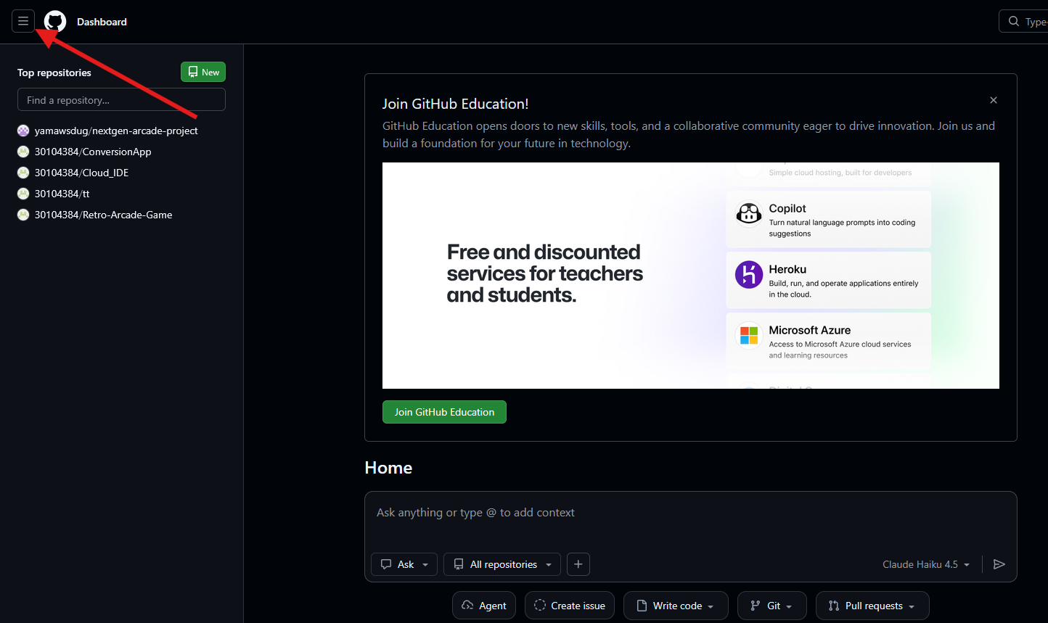
Once the sidebar is open look for “Codespaces” and click on it, this should take you to the codespace dashboard.
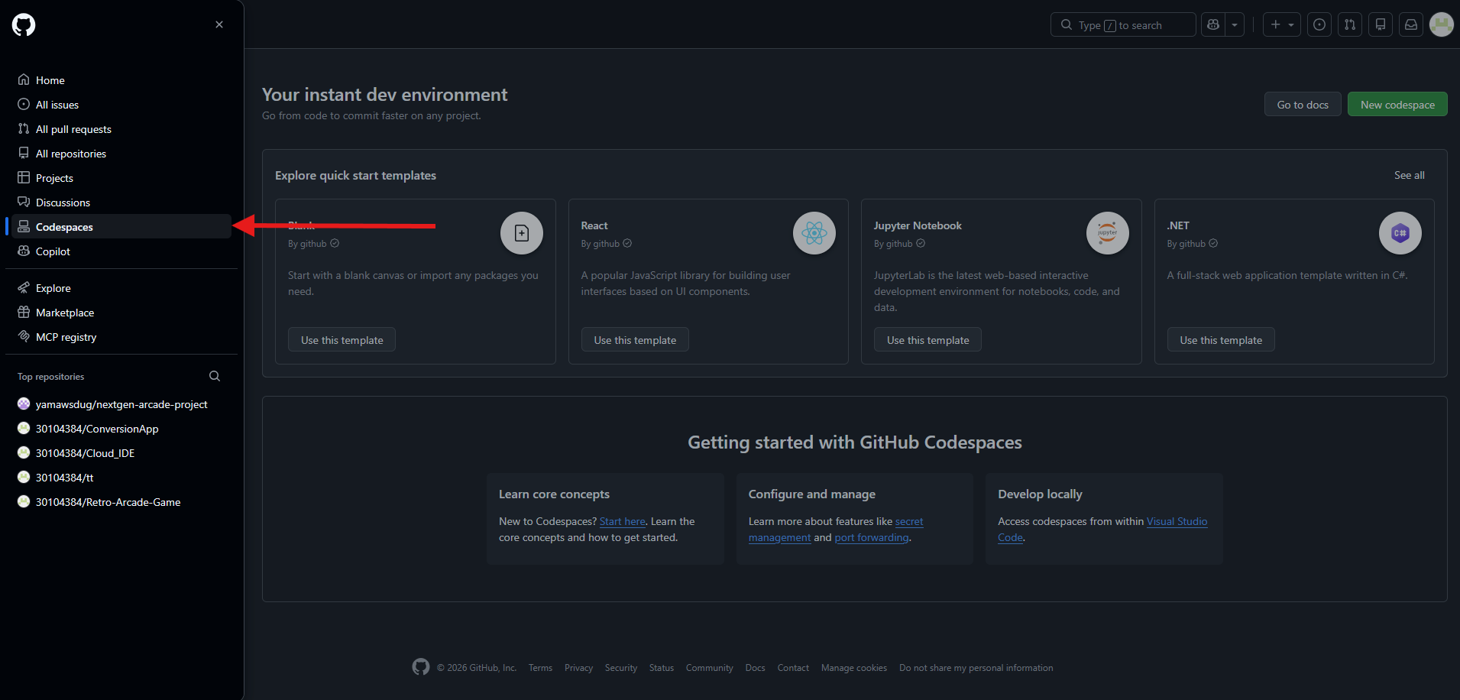
There is multiple templates you can use if you do not wish to create a repository for your code.
For this report we want to press on the green box that says “New codespace”
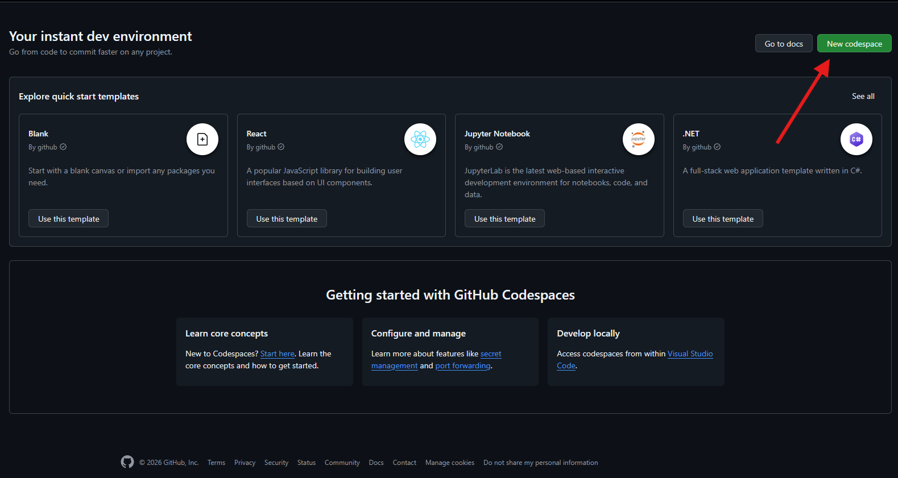

Once you have clicked on new codespace a new tab should open with options to configure it. I chose to select a premade repository for this guide but you can make/select whatever one you want including the templates from before. Once you have configured it click “create codespace”.
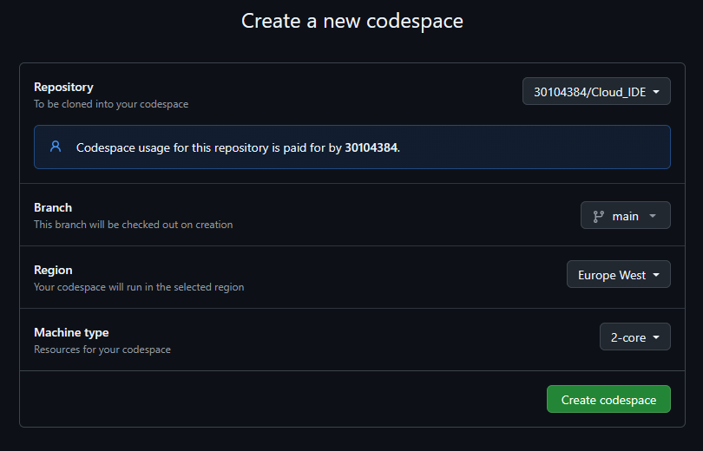
Once you have created your codespace you will be redirected to a form of “VS code”
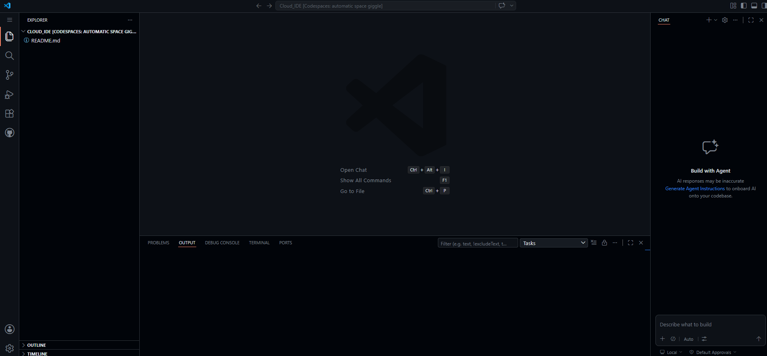

From here I created a folder inside called “src” and then created a file called "Main.java”. this allows you to start coding more efficiently. I opened the Main.java to start entering my code and for this is did a very simple example that allows me to output “Hello world!” and “GitHub Codespaces is working!”
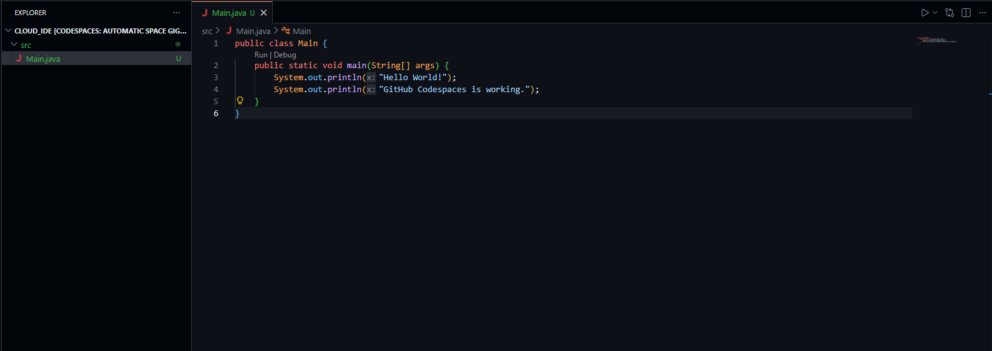
To make sure this does run and do want we want it to do, look for the play button on the top right, sometimes it may ask once pressed to debug, select yes if it does show.
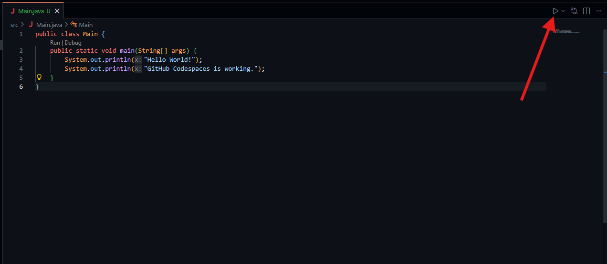
Once it starts running it will open the terminal at the bottom, this will show you what outputs you wanted or it will show you that you have an error in your code.
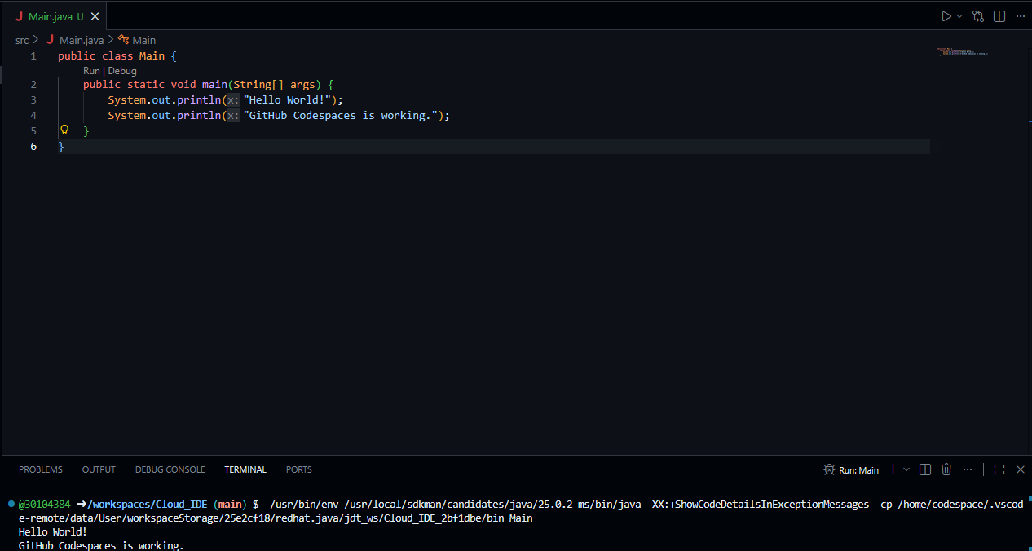
GitHub Codespaces also allows you to create dev containers by simply opening terminal and entering “mkdir .devcontainer”, you will know this worked when a folder called “.devcontainer” shows up on the sidebar above your src folder.
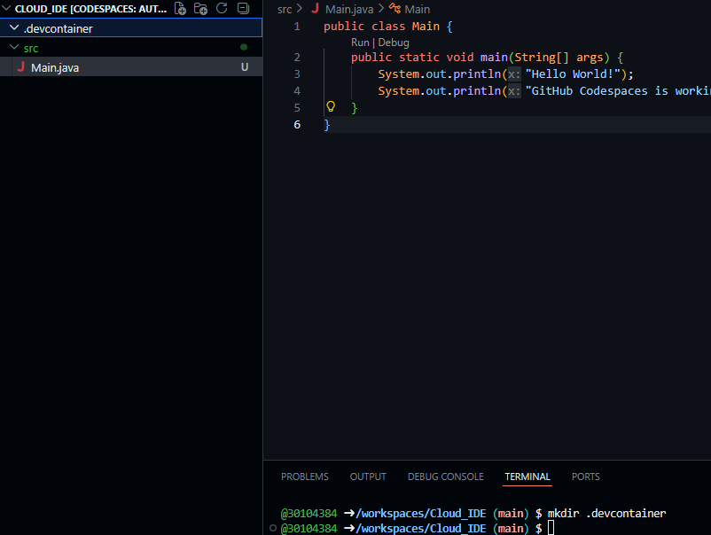

If you want to create a JSON file inside the dev container, open the terminal and enter “touch .devcontainer/devcontainer.json”. You will know if this has worked as there will now be a JSON file inside of .devcontainer.
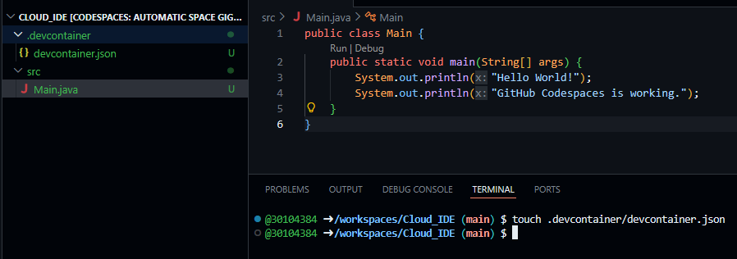
When you open the JSON file it will be empty at first but for this walkthrough you will need to enter these details;
{
"name": "Java Dev Environment",
"image": "mcr.microsoft.com/devcontainers/java:21",
"customizations": {
"vscode": {
"extensions": ["vscjava.vscode-java-pack"]
}
}
}

Once you have entered this into the JSON file a pop up will show asking if you want to rebuild the container, press “Rebuild now”.
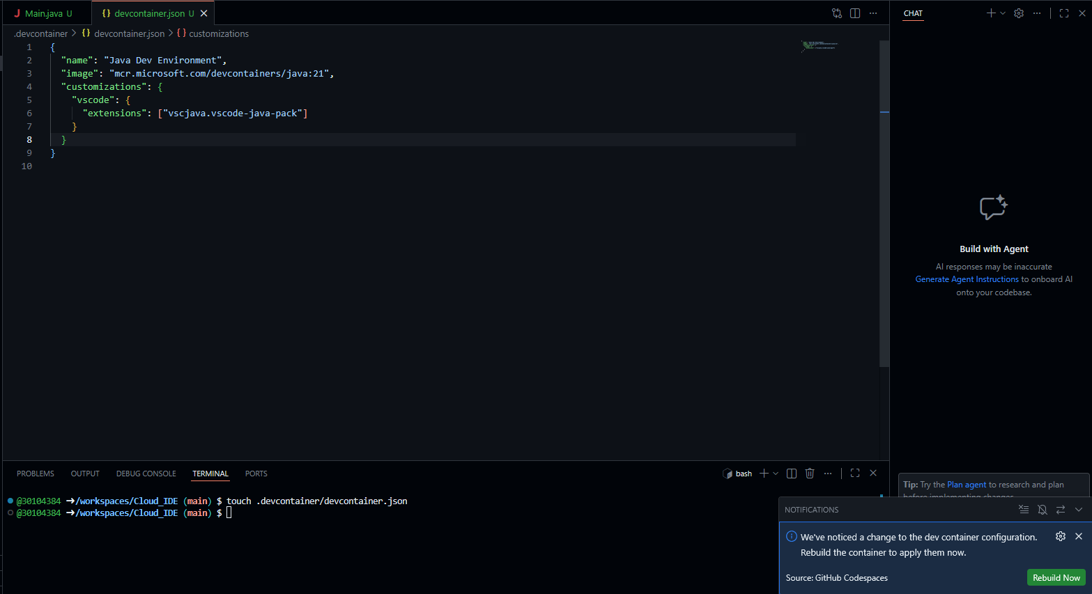

You will see a loading bar while it is rebuilding your codespace, just wait for this to complete.

What this all does is renames the environment details while ensuring that java 21 is used and applied the Java extension pack so you can use more java features with the likes of Maven support. This just helps to ensure that there are less errors and it is far more efficient.

Saving your repository

One of the biggest benefits of using GitHub is that you can save everything to your repository. This is done by using “Commit” this term is similar to saving an edited document.
To find the commit button find and select “source control” from the sidebar. You will see a comment bar, type whatever changes you made here and then hover over what file you want to “stage to commit” and click the plus symbol. Once you are done click “commit” in the green box.
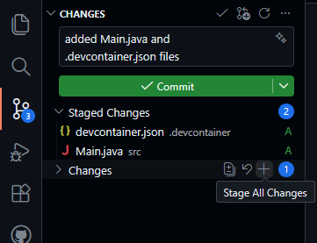
Make sure to also click “sync changes” this shows up after clicking commit.
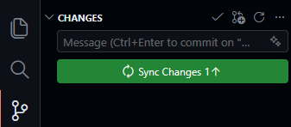
You will know this work if you leave codespace back to GitHub and open up your repository and the folders from the code are there showing they have been added.
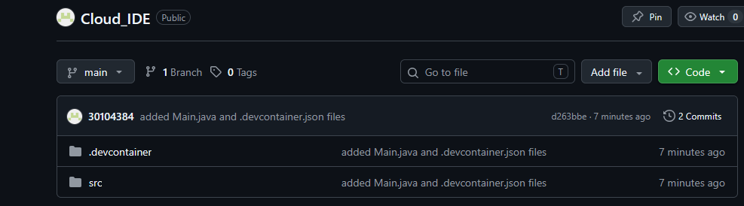

Conclusion
In conclusion, GitHub Codespaces is an effective cloud-based IDE that provides developers with a flexible and accessible programming environment. It allows users to write, edit and run code directly from a webite without needing to install large amounts of software on their local machine. This makes the setup process faster and easier, especially for students or teams working on multiple devices.
GitHub Codespaces also improves collaboration because projects can be shared and worked on in the same environment. Features such as GitHub integration, built-in terminals and configurable devcontainers help create a consistent development setup for all users. This reduces compatibility problems that can happen when developers use different operating systems or software versions.
Overall, GitHub Codespaces is a strong alternative to traditional local IDEs because it combines convenience, accessibility and collaboration in one cloud platform. It is especially useful for education, remote working and team based software development projects.

